Creating an Executable Jar File in the Command Window
In Java, it is common to combine several classes in one .jar ("java archive") file. Library classes are stored that way. You can create your own jar file combining several classes, too. jar files are created using the jar.exe utility program from the JDK.
You use the jar utility with some arguments:
c: create a jar
v: verbose output
f: specify the output jar file name

You can make your jar file runnable by telling jar.exe which class has main. To do that, you need to create a manifest file.
e: create a manifest file: the jar utility will add a manifest file for you.
- For a project with only one class called Example, open a CMD window in the same folder as the project:
jar cvfe MyJar.jar Example Example.class
Example is the class which contains main, Example.class is the compiled file of Example. This is the verbose output you will see on the command line:
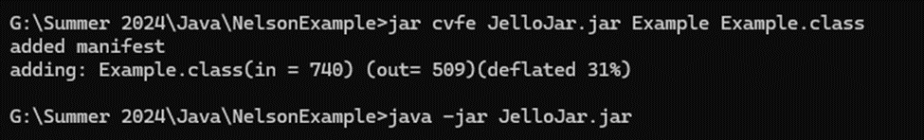

To run the jar, open a CMD window in the same folder as the jar. Type: java –jar MyJar.jar

- For a project with multiple classes, you have to create a jar which lists all of the compiled classes’ files. You can do that by compiling the project and going to the folder that contains the .class files. You can then list them separately. You maty be surprised at the number of .class files that were generated.

You will get a much longer verbose output that reflects the extra classes’ compiled versions as well as the compiled version of any Listeners, since they are implemented as inner classes. Here is an example of listing the other classes:

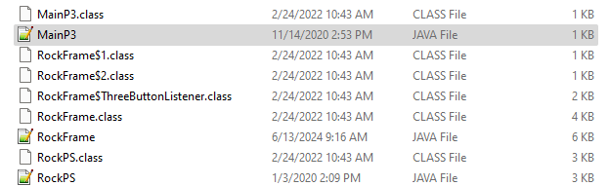

So, it’s easier to just use *.class. Then you get the same output:

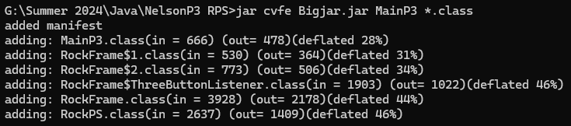

Then run the jar as you did before: java -jar MyJar.jar

